MIS 311 Assignment #1 – Personal Portfolio Site
Part 1: Data Analysis and Insight
1. Data Overview
I selected the dataset “Most Visited Countries”. It contains tourism arrival data from different countries around the world. The dataset includes actual international tourist arrivals in 2022 and 2023, predicted tourist arrivals for 2024, and tourism statistics from the World Bank. The dataset contains 207 rows (including the header row) and 6 columns. The 6 rcolums represent 6 variables: Country, Predicted tourist arrivals in 2024, Tourist arrivals in 2023, Tourist arrivals in 2022, World Bank tourist arrival data and World Bank year.
This dataset shows which countries are experiencing tourism growth each year. It provides a basis for analyzing changes in international tourism patterns over time.
2. Data Cleaning
The dataset was checked for missing values ​​using Excel.
Using the “Go to Special” function, and remove entire blank rows. I identified a total of 188 rows that have missing values. These rows were removed to improve the accuracy and reliability of the data for analysis.
After deleting the missing value, I used Excel's "Remove Duplicates" feature to identify the duplicate information. There were no duplicate rows found in the dataset.
As a result, we have 17 rows left (exclude the header row).
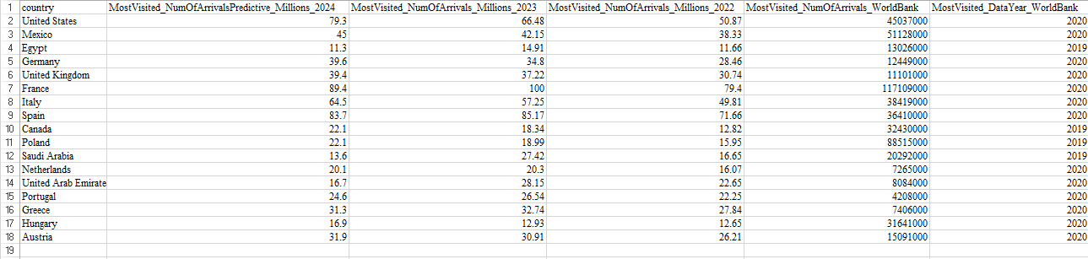
Table 1: Cleaned Dataset
3. Descriptive Statistics
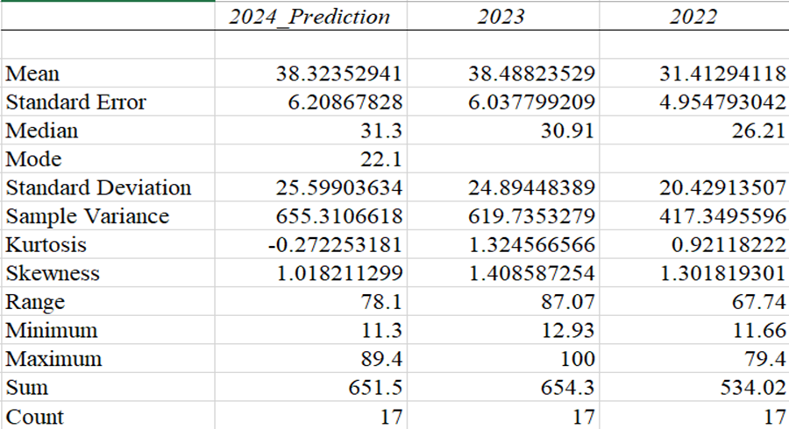
Table 2: Descriptive Statistics Summary
Over all three years, we see an observation count of 17. In the 2024 prediction, we see a mean of 38.32 and a median of 31.3, indicating that most countries have tourist arrivals of over 30 million. The standard deviation value is 25.60, showing a fairly large dispersion of data between countries. Additionally, the range is 78.1 with a minimum of 11.3 and a maximum of 89.4, demonstrating a significant difference between countries with low and high tourist numbers.
In 2023, the mean was 38.49, the highest in three years, and the median was 30.91. The standard deviation value reached 24.89. It indicates a relatively large difference in tourist numbers between countries. Furthermore, the range for 2023 was 87.07, the largest in three years, with a minimum of 12.93 and a maximum of 100, which suggests some countries were attracting significantly more tourists than the rest.
In 2022, with a mean of 31.41 and a median of 26.21, lower than the other two years. The standard deviation value was 20.43, indicating that the data still showed some dispersion, but it was lower than in 2023 and 2024 predictions. Additionally, the range for 2022 was 67.74, with a minimum of 11.66 and a maximum of 79.4.
4. Visualizations
I use “Box and whisker” to present the descriptive statistics.
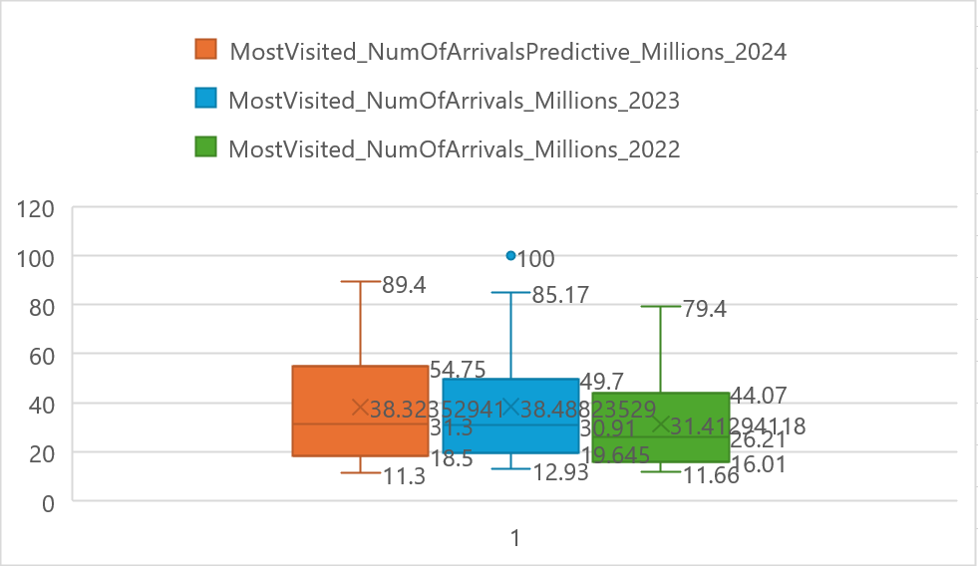
Figure 1: Box Plot of International Tourist Arrivals (2022–2024)
Insight 1
The box plot shows that the mean of tourist arrivals increased from 31.41 million in 2022 to 38.49 million in 2023 and remained high in the 2024 forecast at 38.32 million. Simultaneously, the maximum value also increased from 79.4 million to 100 million in 2023. This indicates that the international tourism industry has recovered strongly and continues to maintain a stable growth trend.
Insight 2
The median of tourists in all three years was lower than the mean and the range in 3 years is significantly high, they are all above 65 million. It suggests that a few countries with very high tourist numbers artificially inflated the overall average of the data. This shows that the distribution of international tourists is uneven, with most being concentrated in popular destinations around the world.

